Date: 06.06.2025
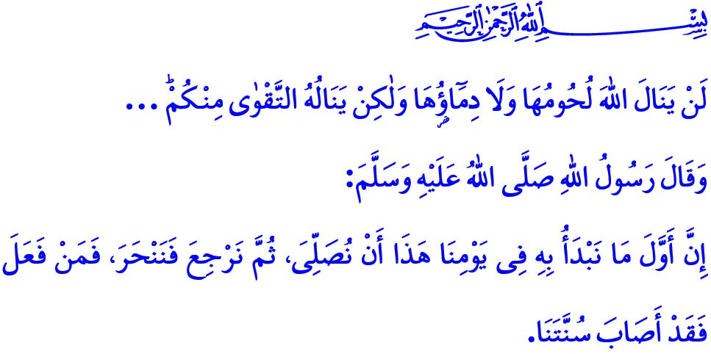
‘EID AL-ADHA: ALLAH THE ALMIGHTY’S FAVOR AND GENEROSITY TO HIS SERVANTS
Honorable Muslims!
Today is the tenth day of the month of Dhu al-Hijjah, the blessed day of ‘Eid al-Adha. Endless praise and gratitude be to our Exalted Lord, who has once again allowed us to reach these sacred days. May peace and blessings be upon our Noble Prophet Muhammad Mustafa (saw), who taught us the wisdom and significance of the ‘Eid, as well as upon his companions and his family. ‘Eid Mubarak! I wish you all a happy ‘eid!
Dear Believers!
The Prophet (saw) addressed the believers on the morning of ‘Eid al-Adha saying, “The first thing to be done on this day is to perform the ‘eid prayer; and after returning from prayer, we slaughter our sacrifices. Whoever does so, he acted according to our sunnah.” Today, we too have come together, shoulder to shoulder, following the Sunnah of the Messenger of Allah (saw). We have become one heart, one body. With sincerity and devotion, we have turned to Allah. Alhamdulillah, we have performed our ‘eid prayer together in a state of reverence. Soon, inshallah, we will fulfill our act of qurbani with takbirs, the basmalah, and supplications.
Esteemed Muslims!
The sacrificial animals are a trust from Allah the Almighty entrusted to us. Therefore, let us treat them with compassion at every stage of the worship of qurbani. In accordance with the advice of the Messenger of Allah (saw), who said: إِنَّ اللّٰهَ كَتَبَ الْإِحْسَانَ عَلَى كُلِّ شَيْءٍ “Indeed, Allah has prescribed excellence (ihsan) in all things,” let us ensure that the slaughtering is carried out properly, in designated places, by qualified and competent individuals. Let us also pay attention to cleanliness during and after offering our qurbani. Let us avoid polluting our surroundings and refrain from causing discomfort to others with unpleasant sights.
The worship of qurbani is about sharing and helping one another. It is about partaking in the table of the needy and becoming a part of the prayers of an orphan. Allah the Almighty says: “Neither their meat nor blood reaches Allah. Rather, it is your piety that reaches Him...” Therefore, in accordance with the etiquette of solidarity as taught by Islam, let us share the meat of our qurbani with our relatives, neighbors, and those in need. Let us bring peace and joy to homes, and love and compassion to hearts.
Dear Believers!
‘Eids are a manifestation of Allah the Almighty’s favor and generosity to His servants. What befits these days is joy and celebration. Our duty is to strive to carry this joy and excitement from our homes to our streets, our cities, and to the entire world. It is to delight the hearts of our children and to spend meaningful and quality time with our youth. It is to strive to leave lasting memories of ‘eid in their lives.
What befits ‘eid is silat al-rahim—maintaining the bonds of kinship. Our responsibility is to visit our parents and relatives, and to earn their heartfelt prayers. It is to include our brothers and sisters in hospitals, care homes, and nursing homes in the joy of ‘eid. It is to visit the graves of our deceased loved ones—especially our honored martyrs—and to pray to our Lord for their forgiveness and mercy.
What befits Eid is to find joy in bringing joy to others. Our duty is to bring comfort to the hearts of orphans, and to be a remedy for their sorrows.
What befits ‘eid is forgiveness and pardon. Our duty is to put an end to grudges and estrangements and to strengthen our unity, solidarity, and brotherhood even further.
Dear Muslims!
On these blessed days when we experience the joy of ‘eid, it is with deep sorrow that we witness innocent lives in Gaza and in various parts of the world awakening to yet another ‘eid morning under the shadow of bombs, hunger, and helplessness. Let us remember once again on this ‘eid morning: A Muslim must never abandon their brothers and sisters to the mercy of oppressors. They must not leave them without help or support. In accordance with the hadith of the Prophet Muhammad (saw), “A Muslim is the brother of another Muslim. He does not oppress him, nor does he abandon him to the enemy...“, they must not withhold our material and spiritual support from them.
I pray to Allah the Almighty that this ‘Eid al-Adha brings blessings to our noble nation, to the Islamic world, and to all of humanity, and that it becomes a means of deliverance for all the oppressed—especially our brothers and sisters in Palestine.
Let us not forget the takbir al-tashriq, which we proclaim with the words: اَللّٰهُ أَكْبَرُ اَللّٰهُ أَكْبَرُ لاَ إِلَهَ إِلاَّ اللّٰهُ وَاللّٰهُ أَكْبَرُ اَللّٰهُ أَكْبَرُ وَ لِلّٰهِ الْحَمْدُ beginning from the Fajr prayer on the Day of ‘Arafah and continuing until the ‘Asr prayer on the fourth day of ‘eid.

I would like to conclude the khutbah of ‘Eid al-Adha with verse 162 of Surah al-An‘am: قُلْ اِنَّ صَلَات۪ي وَنُسُك۪ي وَمَحْيَايَ وَمَمَات۪ي لِلّٰهِ رَبِّ الْعَالَم۪ينَۙ “Say, “Surely my prayer, my sacrifice, my life, and my death are all for Allah—Lord of all worlds.”

Bukhari, ‘Eidayn, 3.
Tirmidhi, Diyat, 14.
Hajj, 22/37.
Muslim, Birr, 58.
An‘am, 6/162. General Directorate of Religious Services

